Christmas at
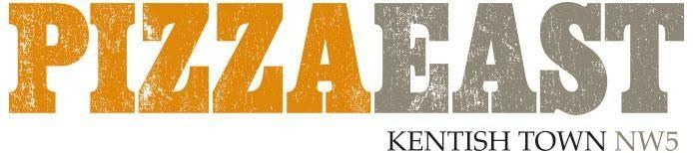
£30 sharing menu for parties of 12 guests or more
Make your selections from the below and our chefs will prepare the perfect amount of food for your party.
Add a glass of Prosecco on arrival for £5 per person.

counter
House selection of meat and cheeses
antipasti

Please choose four
Garlic bread
Short ribs, fontina croquettes
Lamb meatballs, tomato sauce, parmesan
Calamari, prawns, courgette fritti
Burrata, peach, pistachio, truffle honey
Octopus, salsa rossa, salted ricotta

wood oven

Please choose two
Turkey, cranberry stuffing, sourdough bread sauce
Thyme roast rib-eye, horseradish cream
Pork belly, apple sauce
Salt baked salmon, olive tapenade
Mac n cheese
Lasagne

PIZZA

Please choose four
Buffalo mozzarella, tomato, basil
Anchovies, tomato, mozzarella, olives, capers
Portobello mushrooms, pancetta, garlic, cream
Basil pesto, cherry tomato, pine nuts, red onion
Burrata, confit tomato, basil pesto, cream
Salami picante, mozzarella, tomato
Nduja, poponcini, red onion, mozzarella
Spicy pork, cream, mozzarella, broccoli
Veal meatballs, cream, prosciutto, sage
Four cheese, black truffle, fresh oregano
San Daniele, burrata, rocket, tomato

salads

Please choose two
Butter lettuce, avocado, mustard dressing
Rocket, parmesan, pine nuts, fennel
Broccoli, chilli, almond

Desserts

Please choose three
Limoncello posset
Salted chocolate caramel tart
Amarena cheesecake
Christmas pudding, brandy custard

